TEACHER:MWALE CHIPO

DESIGN AND TECHNOLOGY DEPARTMENT
LESSON PLAN

SUBJECT: DESIGN AND TECHNOLOGY CLASS: DATE:……/……./20…. DURATION:………….
BOYS:…………………… GIRLS ………………………………………. TOTAL OF PUPILS… TOPIC: JOINING MATERIALS SUBTOPIC: METAL LEARNING OUTCOMES LSBAT
- Explain Soldering joints
- Explain the uses of fluxes
- Identify types of flux
- Describe sweating joints
RATIONALE
Knowledge: Permanent and Temporary joints. Metal, tin plat joints, soldering, riveting, screwing threads
Skills: Application of different methods of joining materials
Values: Appreciating various joints. Awareness of safety precautions when joining materials
TEACHING AIDS
……………………………………………………………………………………………………………………………………………

PART | LESSON CONTENT | METHO DOLOG Y | LEARNER ACTIVITY
introdu ction | - Recap on the previous lesson | Q/A | Provide answers
Development | JOINING MATERIALS PERMANENT JOINTS  Metal  - Soldering  - Soldering is a process in which two or more metal items are joined together by melting and then flowing a filler metal into the joint  - The filler metal having a relatively low melting point.  - Soldering is used to form a permanent connection between electronic components.  - Soft soldering is used to tinplate work and equally effective in copper, brass, zinc, iron and steel  Fluxes  - It removes any oxidized metal from the surfaces to be soldered,  - Seals out air thus preventing further oxidation  - Flux enables the solder to adhere to the clean metal surface  - Flux also serves as a heat-transfer medium, facilitating heating of the joint by the soldering tool or molten solder.  Types of fluxes  - Passive fluxes serve only to exclude the atmospheres from the clean metal preventing the formation of oxides. Example resin used in powder or paste form  - Active fluxes removal of oxides by chemical reaction. Examples of active zinc chlorides also known as killed sprit  For soft soldering joint to be effective  - The bits need tinning  - The plants must be cleaned  - The parts must be held firmly together  - Sweat Joints  - Large surface that are to be soldered without use of soldering bit, sweating is employed  - The parts to be joined are first tinned and then brought together under light pressure and reheated until the solder runs  - used to describe the process of using heat and solder to join copper pipe and fittings to one another | Questions And Answers  Demonstr ation  V/E | Taking note of important points  Provide answers
Applicat ion | CLASS EXERCISE  - what is Soldering joints  - Explain the uses of fluxes  - Identify two types of fluxes used during soldering | Questions And Answers | Provide answers
Conclu sion | - Recap on the main steps and points | V/E

TEACHER:MWALE CHIPO.

DESIGN AND TECHNOLOGY DEPARTMENT
LESSON PLAN

SUBJECT: DESIGN AND TECHNOLOGY CLASS: DATE:……/……./20…. DURATION:………….
BOYS:…………………… GIRLS ………………………………………. TOTAL OF PUPILS… TOPIC: JOINING MATERIALS SUBTOPIC: RIVETINGS
LEARNING OUTCOMES LSBAT
- Define Riveting?
  - State Types of head rivets
  - Identify types of joints
- Identify and Explain tools used in sheet metal work
RATIONALE
Knowledge: Riveting: rivets heads, types of riveting joints
Skills: Application of different methods of joining materials
Values: appreciating various joints. Awareness of safety precautions when joining materials
TEACHING AIDS
PART | LESSON CONTENT | METHO DOLOG Y | LEARNER ACTIVITY
introdu ction | - Recap on the previous lesson | Q/A | Provide answers
Development | JOINING MATERIALS  Riveting  - The process by which two plates are joined together by use of rivet is called riveting. It is regarded as permanent joint.  Types of head rivets  - Snap head rivet  - Countersunk head  - Pan head  - Flat head  - Pop rivet  Types of joints  - Lap joint with single row rivets  - Double riveted lap joint  - Butt joint with single cover plate  - Double riveted butt joint with cover plate each side  Tools used in riveting process  - Rivet pop rivet gun  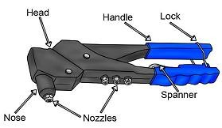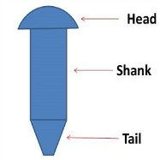  Plastics : laminating Sheet metal work  - Tin plates  Tools used in sheet metal work  - Tin man’s snips- for cutting  - Tin man’s mallet = used in conjunction with stakes or folding bars for shaping and bending  - Hammers  - Forming tools = used for neatly closing down seamed joints, wired edges, right angled folds | Questions And Answers  Demonstr ation  V/E | Taking note of important points  Provide answers
Application | CLASS EXERCISE  - Define Riveting?  - State Types of head rivets  - Identify types of joints  - Identify and Explain tools used in sheet metal work  - Draw and label the parts of the rivet | Questions And Answers | Provide answers
Conclu sion | - Recap on the main steps and points | V/E

TEACHER: MWALE CHIPO

DESIGN AND TECHNOLOGY DEPARTMENT
LESSON PLAN

SUBJECT: DESIGN AND TECHNOLOGY CLASS: DATE:……/……./20….
DURATION:…………. BOYS:…………………… GIRLS …………… TOTAL OF PUPILS… TOPIC: JOINING MATERIALS SUBTOPIC: WOOD LEARNING OUTCOMES LSBAT
  - Define carpentry joint.
  - Identify and explain categories’ of wood joints.

RATIONALE
Knowledge: Permanent and Temporary joints
Skills: Application of different methods of joining materials
Values: various joints. Awareness of safety precautions when joining materials

TEACHING AIDS
………………………………………………………………………………………………………………………………
PART | LESSON CONTENT | METHO DOLOG Y | LEARNER ACTIVITY
Introdu ction | - Recap on the previous lesson | Q/A | Provide answers
Development | WOOD JOINTS  CARPENTRY JOINT  - Joints between two wooden pieces CATEGORIES OF WOOD JOINTS Widening joints  - A Widening Joint is used to create a wide board from several narrower boards by joining them end to end.  - They are mainly used for making table tops which needs a wider board Examples  - Butt joint  - Dovetailed joint  - Tongue and groove joint  Lengthening Joint  Examples  - Lap Joint, Fishing Joint, Scarfed Joint  Bearing Joint  Examples  - Dove tail joint., Mortise and tenon joint, halved joint, Halved joint  Angle or Corner Joint  - Used to Join corners of frame Examples  - Plain Mitred  - Shoulder Housed  - Dovetailed Housed  - Housed Tongue &Groove &mitred  Framing joints  Example  - mortise and tenon joint  - butt  - flat miter | Questions And Answers  Demonstr ation  V/E | Taking note of important points  Provide answers
Applicatio n | CLASS EXERCISE  - Define carpentry joint.  - Identify and explain categories’ of wood joints. | Questions And Answers | Provide answers
Conclu sion | - Recap on the main steps and points | V/E

TEACHER: MWALE CHIPO

DESIGN AND TECHNOLOGY DEPARTMENT
LESSON PLAN

SUBJECT: DESIGN AND TECHNOLOGY CLASS: DATE:……/……./20….
DURATION:…………. BOYS:…………………… GIRLS …………… TOTAL OF PUPILS… TOPIC: JOINING MATERIALS (WOOD) SUBTOPIC: JOINTS LEARNING OUTCOMES LSBAT
  - Identify and explain different types of wood joints.

RATIONALE
Knowledge: Permanent and Temporary joints. Wood joints
Skills: Application of different methods of joining materials
Values: various joints. Awareness of safety precautions when joining materials

TEACHING AIDS
………………………………………………………………………………………………………………………………
PART | LESSON CONTENT | METHO DOLOG Y | LEARNER ACTIVITY
introdu ction | - Recap on the previous lesson | Q/A | Provide answers
Development | WOOD JOINTS  Butt Joint  - It joins two pieces of wood by merely butting them together.  - The butt joint is the simplest joint to make.  - It is also the weakest wood joint unless you use some form of reinforcement.  - It depends upon glue alone to hold it together.  Bridle Joint  - A bridle joint is a woodworking joint, similar to a mortise and tenon.  Dovetail Wood Joint  - The dovetail joint is a strong woodworking joint.  - It is great for tensile strength (resistance from pulling apart).  PARTS OF DOVETAIL JOINT  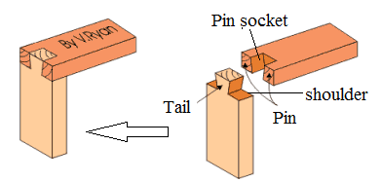  Housing joints  - Housing joints are used when two pieces meet at right angles on their narrow face  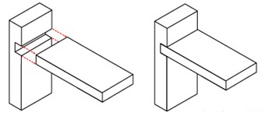  Finger Joint box joint  - Used to join two pieces of wood at right angles to each other.  - It is much like a dovetail joint except that the pins are square and not angled
Appli catio | CLASS EXERCISE  - Draw and label the parts of dovetail joints.  - Apart from dovetail joint State any three types of wood joints | Questions And Answers | Provide answers
Conclu sion | - Recap on the main steps and points | V/E

TEACHER: MWALE CHIPO

DESIGN AND TECHNOLOGY DEPARTMENT
LESSON PLAN

SUBJECT: DESIGN AND TECHNOLOGY CLASS: DATE:……/……./20….
DURATION:…………. BOYS:…………………… GIRLS …………… TOTAL OF PUPILS… TOPIC: JOINING MATERIALS (WOOD) SUBTOPIC: JOINTS LEARNING OUTCOMES LSBAT
  - Identify and explain different types of wood joints.

RATIONALE
Knowledge: Permanent and Temporary joints. Wood joints
Skills: Application of different methods of joining materials
Values: various joints. Awareness of safety precautions when joining materials

TEACHING AIDS
………………………………………………………………………………………………………………………………
PART | LESSON CONTENT | METHO DOLOG Y | LEARNER ACTIVITY
Introdu ction | - Recap on the previous lesson | Q/A | Provide answers
Development | WOOD JOINTS  Mortise and Tenon  - One of the strongest joints.  - This joint is simple and strong PARTS OF MORTISE AND TENON JOINT  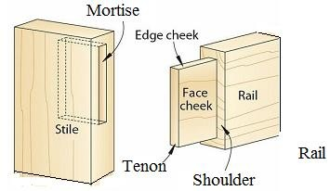  Mitered butt joint  - The two boards are joined at an angle (instead of square to one another).  - The advantage is that the mitered butt joint will not show any end grain,  - Mitered butt joint isn't all that strong.  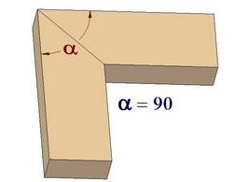  Dowelling  - Dowels are round wooden pins of small diameter used strengthen (reinforce) to a joint.  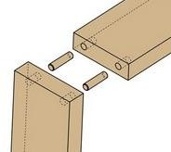
Appli catio | CLASS EXERCISE  - Draw and label the parts of mortise and tenon joints.  - State one advantage of mitred joint | Questions And Answers | Provide answers
Conclu sion | - Recap on the main steps and points | V/E

MARKING OUT AND CUTTING A DOVETAIL JOINT MARKING AND CUTTING THE PINS
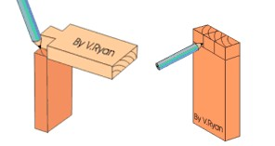 | The first side is placed above the second side of the joint and the pins are marked out.  Again a pencil is used although the traditional tool would be a marking knife
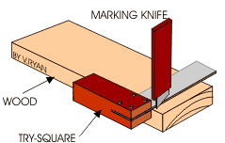 | Marking out the joint when both pieces are together can be difficult but a steel ruler or a try square can be used to straighten any lines. Again, the waste wood must be clearly identified
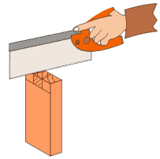 | A dovetail / tenon saw is used to cut down the lines marking the pins. The wood must be secured in the vice in the same way as before. Remember, the saw is used to cut straight down the joint, on the waste side of the pencil line.
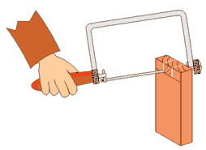 | A coping saw is used to remove the waste wood. Again the wood is secured in the vice
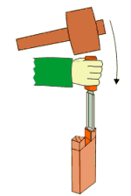 | A chisel is used to finish the joint, if it is needed. The wood is placed in a woodworkers vice so that it cannot slip. The joint should fit together if care has been taken when marking out and cutting the two sides
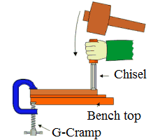 | If the pin is slightly inaccurate a firmer or bevel edged chisel can be used to correct it. A G cramp is used to hold the wood firmly. Scrap wood is placed underneath to protect the surface of the bench from the chisel. The second side of the joint should now be complete.
 | The completed dovetail joint

TEACHER: MWALE CHIPO.

DESIGN AND TECHNOLOGY DEPARTMENT
LESSON PLAN

SUBJECT: DESIGN AND TECHNOLOGY CLASS: DATE:……/……./20…. DURATION:………….
BOYS:…………………… GIRLS ………………………………………. TOTAL OF PUPILS… TOPIC: JOINING MATERIALS SUBTOPIC: ADHESIVES LEARNING OUTCOMES LSBAT
  - Define Adhesives
  - State three groups of adhesives
  - Identify and explain Types of adhesives
RATIONALE
Knowledge: Casein, animal, PVA, contact glue,
Skills: Application of different types of adhesives when joining materials
Values: Awareness of safety precautions when applying adhesives.
TEACHING AIDS.
PART | LESSON CONTENT | METHO DOLOG Y | LEARNER ACTIVITY
introdu ction | - Recap on the previous lesson | Q/A | Provide answers
Development | ADHESIVES  - Wood adhesives are bonding substances used for fixing joints or pieces of work permanently  Groups Of Adhesives  - Protein adhesives  - Synthetic resin adhesives  - Contact/impact glues adhesives  Types of adhesives  - Animal Glue .made from the bones, hooves, horns and hides of animal disadvantage of animal glue  - it must be used very quickly as it starts so set or dry on cooling  - it is unsatisfactory in damp conditions as the glues absorbs water and soften  - Casein Glue  - Form of white powder and requires to be mixed with cold water to think consistency for use.  - It is resistant to heat and damp but is not waterproof.  - Glue us made from card of sored milk.  - It is liable to stain hardwoods  - Resin Glue  - It is waterproof and this reason is used for boat building.  - It is heat resistant and does not stain but more expensive  - Ready to use in a handy plastic container  - Polyvinyl Acetate (PVA) Glue  - Water based glue  - It is used cold and requires no preparation  - Used for internal work, such as gluing of frames, cold and cold veneering and for fixing wood and plastics to porous surfaces such as hardboard, ceramic, fabric, coke, lather and papers  - This glue is not suitable for joining non-porous materials such as metals  - Contact Glue  - Are instant bonding glue  - They are manufactured by dissolving synthetic rubber, particularly neopline in solvents  - Used for bonding dissimilar (different) and similar materials such as Formica, fabrics, leather, leather, glass, plywood and particles boards, wood to wood , glass to glass
Applicati on | CLASS EXERCISE  - Define Adhesives  - State three groups of adhesives  - Explain the uses of the following adhesives casein glue , Resin glue , Contact glue | Questions And Answers | Provide answers
Conclu sion | - Recap on the main steps and points | V/E

TEACHER: MWALE CHIPO
KENNETH KAUNDA SECONDARY SCHOOL DESIGN AND TECHNOLOGY DEPARTMENT
LESSON PLAN

SUBJECT: DESIGN AND TECHNOLOGY CLASS: DATE:……/……./20…. DURATION:………….
BOYS:…………………… GIRLS ………………………………………. TOTAL OF PUPILS…
TOPIC: FIXINGS SUBTOPIC: FIX IRON MONGERIES
LEARNING OUTCOMES LSBAT
  - Define Fix iron mongeries
  - Explain Three function of Mongeries
  - Identify and Explain types fix iron mongeries
  - Draw and label the parts of screws
  - Explain the types of screws
RATIONALE
Knowledge: Iron monger for security; locks, mortise locks, rim locks, night latch, straight barrel bolt. Screws
Skills: Identification of different types of fixings
Values: Observation of safety precautions required when working on fixing
TEACHING AIDS
PART | LESSON CONTENT |  |  | METHOD OLOGY | LEARNER ACTIVITY
introduct ion | - Recap on the previous lesson |  |  | Q/A | Provide answers
FIXINGS
FIX IRON MONGERIES
- Refer to metallic components are applied on a cabinet works and constructions works
Three function of Mongeries
- For allowing movement for example hinges on the windows and doors
- For fixation or penetration – for examples nails and screws including bolts
- Drawer locks, mortise locks, padlocks night latch, straight barrel bolt , tower bolts
Types fix iron mongeries
- Drawer locks
  - Mainly fixed at the top but central front part of a drawer
  - By locking it help to services items in the drawer or cupboards
- Mortise lock
  - Fixed on the door and It provides security and privacy inside rooms within the building
- Rim lock
  - Fixed on match boarded doors like battened, braced and ledge doors shutter
  - Only operated on the inside part of the room but not outwards
- Straight barrel bolts
  - Used for bolting doors of all rinds
- Ball and catches
- Box lock Screws
  - Wood screws are primary used for joining wood to wood.
  - They also used for fixing fitting such as hinges, locks and handles
Parts of screws
 |  | 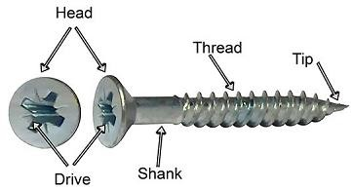 | Types of screws Countersink screw.  Suitable for fixing hinges, and as reinforcement in joinery works  Round head screw  suitable for fitting like thin sheets of materials to wood which is too thin to be countersunk Raised head screws  It provides head attractive finish to the job especially if it made of brass metal
Application | CLASS EXERCISE  - Define Fix iron mongeries  - Explain Three function of Mongeries  - Mention any three types of Mongeries  - Draw and label the parts of screws  - State three types of screws |  |  | Questions And Answers | Provide answers
Conclusi on | - Recap on the main steps and points |  |  | V/E
LESSON EVALUATION

KENNETH KAUNDA SECONDARY SCHOOL DESIGN AND TECHNOLOGY DEPARTMENT

LESSON PLAN
TEACHER: MWALE CHIPO
SUBJECT: DESIGN AND TECHNOLOGY CLASS: DATE:……/……./20…. DURATION:………….
BOYS:…………………… GIRLS ………………………………………. TOTAL OF PUPILS…
TOPIC: FIXINGS SUBTOPIC: NAILS
LEARNING OUTCOMES LSBAT
- Explain types of nails and their uses
- Identify and explain methods of nailing
- Mention types of hinges
RATIONALE
Knowledge: For Penetration- nails, panel pin, ova, roofing nails, hinges: butt, rising butt hinge, scotch tee hinge
Skills: Identification of different types of fixings (nails) Values: Awareness of different types of fixings, TEACHING AIDS.
PART | LESSON CONTENT | METHO DOLOG Y | LEARNER ACTIVITY
introdu ction | - Recap on the previous lesson | Q/A | Provide answers
Development | Nails  - They are most commonly used for joining pieces of timber or for fastening materials to timber and are suitable when a screw is unnecessary  Types of nails  1. Roofing nails  - These have larger heads and are often used for fixing corrugated iron sheets and asbestos sheets into the root framework  2. Oval Wire Nail  - This is a long nail and care must be taken when it is hammered into the wood  - Used for general purpose  - The oval sectional shank is designed to reduce the risk of splitting wood  3. Lost head nails  - Finishing nails that has with a narrow shank  - Stronger than wire nails, meaning they can easily be punched below the surface of the wood.  4. Panel pins  - The lightweight panel pin is perfect for fixing the back of cupboards and wardrobes  - Can be punched below the wood surface  - Cloud nails  - The veneer pin  - Wiggle or corrugated box fastener Method of nailing  - Parallel nailing  - Nails are driven into wood at right angle to the work piece  - Dovetail nailing  - Nails is fist held at an angle to the surface and then driven into the wood  - This methods gives the work pieces additionally holding power  - Clenching nailing  - Method of nailing in which a nail is driven through two pieces of wood and the extra portion is bent over  - This method is used where increased strength is required  IRON MONGERIES FOR MOVEMENT PURPOSE  Hinges  - Are metallic component designed to permit movement in cabinet or construction works.  Types of hinges  a. But hinge, Lift off hinge, Tee hinge , Back flap hinge
Applicatio n | CLASS EXERCISE  - Explain types of nails and their uses  - Identify and explain three methods of nailing  - Define hinge  - Mention any four types of hinges | Questions And Answers | Provide answers
Conclus ion | - Recap on the main steps and points | V/E

